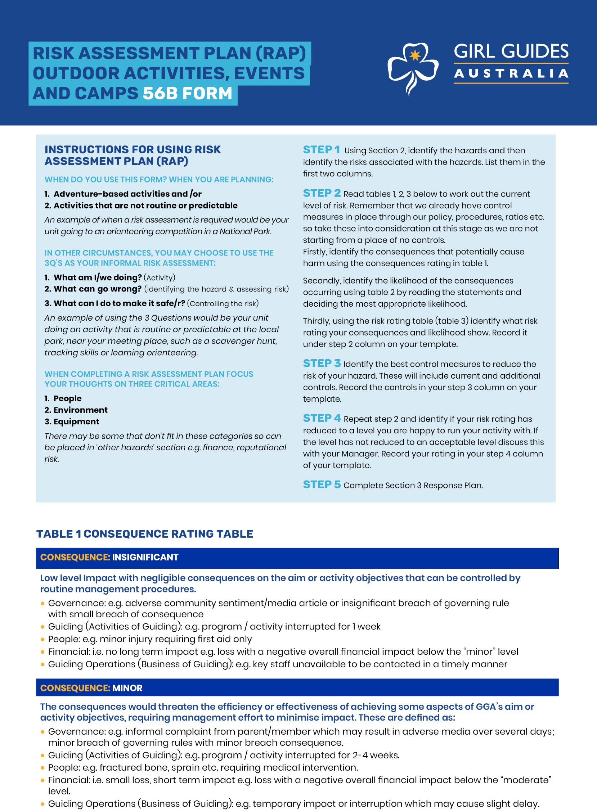

© Copyright Girl Guides Australia – Risk Assessment Plan October 2022 Page 1 of 5

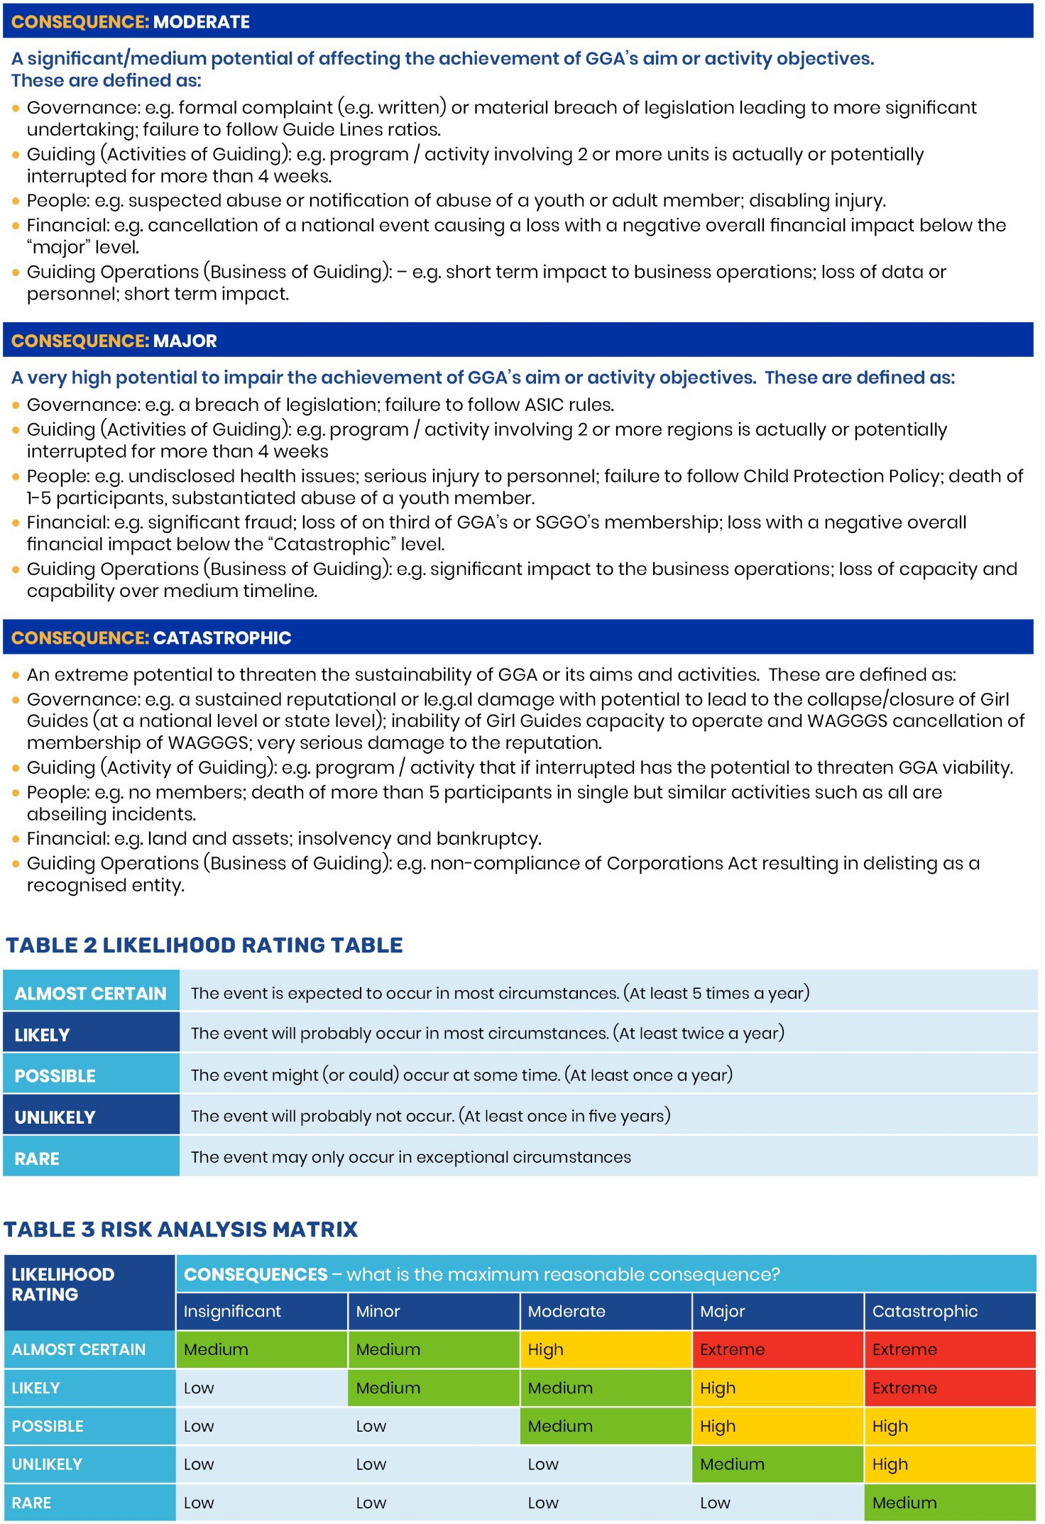

© Copyright Girl Guides Australia – Risk Assessment Plan October 2022 Page 2 of 5

|  |  |  |  |  |  |  |  |
| --- | --- | --- | --- | --- | --- | --- | --- |
| **Section 1. Details of Activity requiring Risk Assessment** | | | | | | | |
| **Activity Type** |  | | | **Outline of Activity** |  | | |
| **Location for Activity** |  | | | **Date/s of Activity** |  | | |
| **Unit/Peer Group** |  | **District/s** |  | **Region** |  | **State** |  |
| **Chair of Committee** |  | | |  |  | | |
| **Leader-in-Charge** |  | | | **Qualifications of LiC** |  | | |
| **First Aider** |  | | | **Qualifications of**  **First Aider** |  | | |
| **Aims of Activity** |  | | | **Risk Assessment**  **prepared by** |  | | |

|  |  |  |  |  |  |
| --- | --- | --- | --- | --- | --- |
| **Section 2. Risk Assessment** | | | | | |
| **People Hazards (e.g., skill, experience, health and fitness, age, fears)** | | | | | |
| **Step 1. Identify the hazards** | | **Step 2. Assess the current risk**  **See tables 1,2,3** | **Step 3. Control the risk** | **Who & When** | **Step 4. Reassess the risk Use table 1,2,3 again** |
| Identify the hazards | What harm is associated with the hazard? | Is the risk low, medium, high or extreme? | What controls are already in place and what else needs to be done to reduce or remove the risk? | By whom?  By when? | Reassess the risk now that controls have been put in place |
|  |  |  |  |  |  |
|  |  |  |  |  |  |
|  |  |  |  |  |  |
|  |  |  |  |  |  |

# © Copyright Girl Guides Australia - Risk Assessment Plan October 2022 Page 3 of 5

|  |  |  |  |  |  |
| --- | --- | --- | --- | --- | --- |
| **Environmental Hazards (e.g., weather, remoteness, terrain, water, shelter)** | | | | | |
| Identify the hazards | What harm is associated with the hazard? | Is the risk low, medium, high or extreme? | What controls are already in place and what else needs to be done to reduce or remove the risk? | By whom?  By when? | Reassess the risk now that controls have been put in place |
|  |  |  |  |  |  |
|  |  |  |  |  |  |
|  |  |  |  |  |  |
|  |  |  |  |  |  |
| **Equipment Hazards (e.g., clothing, kayaks, camping equipment, cars)** | | | | | |
|  |  |  |  |  |  |
|  |  |  |  |  |  |
|  |  |  |  |  |  |
|  |  |  |  |  |  |
| **Other Hazards (e.g., finance, reputation)** | | | | | |
|  |  |  |  |  |  |
|  |  |  |  |  |  |
|  |  |  |  |  |  |
|  |  |  |  |  |  |

|  |  |  |  |  |
| --- | --- | --- | --- | --- |
| **Step 1. Identify the hazards** | **Step 2. Assess the current risk**  **See tables 1,2,3** | **Step 3. Control the risk** | **Who & When** | **Step 4. Reassess the risk Use table 1,2,3 again** |

|  |  |  |  |  |  |
| --- | --- | --- | --- | --- | --- |
| **Section 3. Response Plan** | | | | | |
| **Evacuation Response Procedures e.g., fire, flood** | | | | | |
|  | | | | | |
|  | | | | | |
|  | | | | | |
|  | | | | | |
| **Emergency Response Procedures** | | | | | |
| What? | Equipment? | | | Where located? | |
|  |  | | |  | |
|  |  | | |  | |
|  |  | | |  | |
|  |  | | |  | |
| **Onsite Emergency Contacts** | | | | | |
| Name | | Phone Number | | | |
| Name | | Phone Number | | | |
| **Offsite emergency contacts - Phone Numbers** | | | | | |
| Emergency Services | Police, Ambulance, Fire 000 | | Police Link: 13 14 44 | | Poison Hotline: 13 11 26 |
| Local Health Services  (to the event) |  | |  | |  |
| Girl Guides |  | |  | |  |