Managing Operational Risk

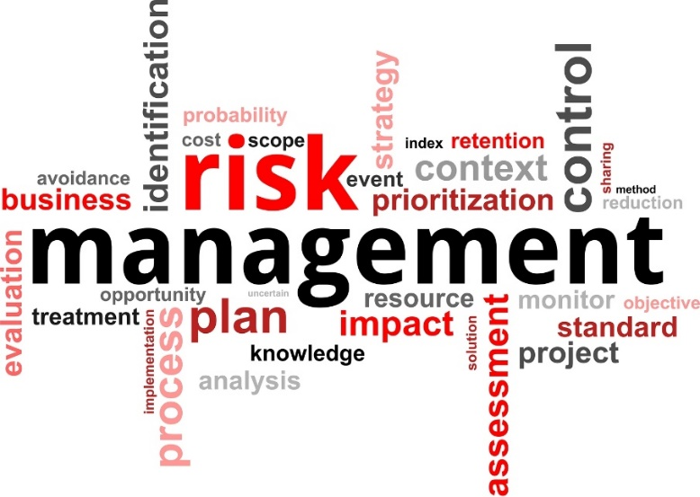

Reference Manual

Girl Guide vision
We believe in delivering innovative, fun and relevant programs in a practical and safe environment.

Guiding in Australia believes we will achieve this vision through our risk management processes.

What is Risk Management?
Risk Management is the culture, process and structure that is directed towards the effective management of potential opportunities and adverse effects within the Girl Guide environment.

Risk management is an opportunity to identify our hazards and the risks that come from them.

Our Risk Appetite
We, in Guiding, have an appetite to take reasonable risks. We are not risk averse.

We ask that members and volunteers be accountable for their behaviors and take reasonable care with their actions and don’t walk past things that they know to be unsafe. By following Girl Guides Australia policy and procedures we will work together to maintain the health and safety of those around us.

We do have a limited number of zero tolerances. These are things we will not accept as an organization:
- fatalities within our scope of influence
- serious injuries as a consequence of negligence
- poor behaviours including systemic bullying or culture of intimidation that impact on the well-being of our members, volunteers and staff.

Why do we manage operational risks?
- To keep us a viable and highly respected girl organisation (financial, reputation, privacy, data security, social media)
- For our own physical and psychological safety (Reputation, WHS)
- To grow competent leaders in your District and Region
- For the safety of the girls (Child Protection, WHS)
- To meet legal requirements of ‘reasonable care’ (WHS Act 2011)

What are the main risks to Districts and Regions?
- Safety
- Financial
- Unqualified leaders
- Non approvals for events
- Reputation
- Child protection
- Intellectual property
- Social media
- Property

What documents are there to support Managers make sound decisions?
1. Girl Guides Australia Policy, Procedure and Guidelines
2. Guide Lines
3. GGA Risk Assessment Plan for Operational Risk (ORP)
4. ISO 31000:2009 Risk Management Standard

When do I complete the Risk Assessment for Operational Risks (ORP)?

Every Region and District is encouraged to complete a health check once a year with its teams i.e. support group, committee members. This health check identifies critical issues that the Region and District will need to address for the forthcoming period of time ie over the next 6 months.

Every time a significant decision needs to be made ie opening a unit, closing a unit, outlaying a large sum of money for a project, retiring a leader.

How do we manage the risk?
We use a process called risk assessment which:
- Identifies the hazard,
- Assesses the initial risk of the hazard
- Select controls to manage the risk of the hazard
- Assesses the residual risk of the hazard

Step 1: Identify the Hazard

What are hazards and risk?
A hazard is anything in the workplace that has the potential to harm people. Under law, Girl Guides is considered a workplace.

A risk arises when it's possible that a hazard will actually cause harm. The level of risk will depend on factors such as how often the activity is done, the number of members or amount of money involved and how serious any consequences that result could be.

When completing a ORP focus your thoughts on GGA’s 5 key risk areas, called Risk Buckets. These are:

- Governance
Risk to reputation and risk to governing rules (legal liability)

2. Guiding (Activities of Guiding)

Risk that activities are not appropriate to the philosophy, principles and method of Girl Guides Australia. Activities are planned that are not suitable and do not meet the developmental needs of the participants.

3. People
The physical, emotional, and psychological well-being of all members and participants is paramount to our beliefs. Includes all members (youth and adult), volunteers, parents, activity providers, general public, business associates.

4. Financial
Financial consequence linked to cost of loss associated with risk

5. Guiding Operations (Business of Guiding)
Day to day running i.e. unit leader-consent forms not completed, activity notification forms not completed.
Includes data integration, marketing, communications, compliance with business legislation, capacity and capability of units/districts/State Guide offices to manage the business side of Guiding.

Step 2: Assess the Initial Risk
Once hazards have been identified you need to assess the risk. We do this twice: first to identify the initial risk rating and then again once we have chosen our control measures to show the residual risk rating.

We start with the consequences and move to the likelihood of an injury or illness occurring from exposure to the hazard.

When assessing the risk, we consider two key factors; initial consequence and initial likelihood

There are three tables in our ORP process that help us:

- Consequence table – this helps us work out how severe the consequences could be. You will notice that the risk buckets appear again here.

- Likelihood table – this helps us work out us how often this may occur.

- Risk analysis table – this gives us the risk rating. If you apply your consequence rating and your likelihood rating the risk analysis matrix will then suggest a current risk rating. This will help you to decide if we need to put more controls in place to make the activity less risky. We then use the matrix again, applying the new controls to give us a new rating.

TABLE 1 Consequence Rating Table
CONSEQUENCE | DESCRIPTION
Insignificant | Low level Impact with negligible consequences on the aim or activity objectives that can be controlled by routine management procedures.  - Governance: e.g. adverse community sentiment/media article or insignificant breach of governing rule with small breach of consequence.  - Guiding (Activities of Guiding): e.g. program / activity interrupted for 1 week.  - People: e.g. minor injury requiring first aid only.  - Financial: i.e. no long term impact e.g. loss with a negative overall financial impact below the “minor” level.  - Guiding Operations (Business of Guiding): e.g. key staff unavailable to be contacted in a timely manner.
Minor | The consequences would threaten the efficiency or effectiveness of achieving some aspects of GGA’s aim or activity objectives, requiring management effort to minimise impact. These are defined as:  - Governance: e.g. informal complaint from parent/member which may result in adverse media over several days; minor breach of governing rules with minor breach consequence.  - Guiding (Activities of Guiding): e.g. program / activity interrupted for 2-4 weeks.  - People: e.g. fractured bone, sprain etc. requiring medical intervention.  - Financial: i.e. small loss, short term impact e.g. loss with a negative overall financial impact below the “moderate” level.  - Guiding Operations (Business of Guiding): e.g. temporary impact or interruption which may cause slight delay.
Moderate | A significant/medium potential of affecting the achievement of GGA’s aim or activity objectives. These are defined as:  - Governance: e.g. formal complaint (e.g. written) or material breach of legislation leading to more significant undertaking; failure to follow Guide Lines ratios.  - Guiding (Activities of Guiding): e.g. program / activity involving 2 or more units is actually or potentially interrupted for more than 4 weeks.  - People: e.g. suspected abuse or notification of abuse of a youth or adult member; disabling injury.  - Financial: e.g. cancellation of a national event causing a loss with a negative overall financial impact below the “major” level.  - Guiding Operations (Business of Guiding): – e.g. short term impact to business operations; loss of data or personnel; short term impact.
Major | A very high potential to impair the achievement of GGA’s aim or activity objectives. These are defined as:  - Governance: e.g. a breach of legislation; failure to follow ASIC rules.  - Guiding (Activities of Guiding): e.g. program / activity involving 2 or more regions is actually or potentially interrupted for more than 4 weeks  - People: e.g. undisclosed health issues; serious injury to personnel; failure to follow Child Protection Policy; death of 1-5 participants, substantiated abuse of a youth member.  - Financial: e.g. significant fraud; loss of on third of GGA’s or SGGO’s membership; loss with a negative overall financial impact below the “Catastrophic” level.  - Guiding Operations (Business of Guiding): e.g. significant impact to the business operations; loss of capacity and capability over medium timeline.
Catastrophic | An extreme potential to threaten the sustainability of GGA or its aims and activities. These are defined as:  - Governance: e.g. a sustained reputational or le.g.al damage with potential to lead to the collapse/closure of Girl Guides (at a national level or state level); inability of Girl Guides capacity to operate and WAGGGS cancellation of membership of WAGGGS; very serious damage to the reputation.  - Guiding (Activity of Guiding): e.g. program / activity that if interrupted has the potential to threaten GGA viability.  - People: e.g. no members; death of more than 5 participants in single but similar activities such as all are abseiling incidents.  - Financial: e.g. land and assets; insolvency and bankruptcy.  - Guiding Operations (Business of Guiding): e.g. non-compliance of Corporations Act resulting in delisting as a recognised entity.

TABLE 2 Likelihood Rating Table

LIKELIHOOD | DESCRIPTION
Almost Certain | The event is expected to occur in most circumstances. (At least 5 times a year)
Likely | The event will probably occur in most circumstances. (At least twice a year)
Possible | The event might (or could) occur at some time. (At least once a year)
Unlikely | The event will probably not occur. (At least once in five years)
Rare | The event may only occur in exceptional circumstances

TABLE 3 Risk Analysis Matrix

LIKELIHOOD RATING | CONSEQUENCES – what is the maximum reasonable consequence?
 | Insignificant | Minor | Moderate | Major | Catastrophic
Almost Certain | Medium | Medium | High | Extreme | Extreme
Likely | Low | Medium | Medium | High | Extreme
Possible | Low | Low | Medium | High | High
Unlikely | Low | Low | Low | Medium | High
Rare | Low | Low | Low | Low | Medium

Step 3 Control the initial risk
We now choose the control measures to reduce the initial risk.

You may like to use the Hierarchy of Control and its levels to help you work out the best control for your risks. Start at the top for the most effective way of reducing your hazard and work your way down until you are happy that you have controlled your risk.

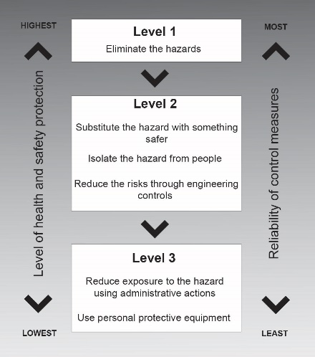

Step 4 – Assess residual risk

Now we repeat step 2 having chosen our control measures and reassess the risk rating, taking into consideration our chosen control measures.
Once you have completed your residual risk rating you need to ensure that it is acceptable. If it sits in the high or extreme risk priority category you will need to escalate the risk concern to the next level. The higher the risk the higher the priority and the sooner you need to deal with the hazard.

TABLE 4 Risk Priority Table
RISK PRIORITY | ACTION TO BE TAKEN
Extreme | An Extreme Risk is one that must be dealt with immediately. State Girl Guide Organisations and Girl Guides Australia Boards normally monitor Extreme Risks.
High | A High Risk is one that should be dealt with after attending to Extreme Risks. High level risks may be managed at State Commissioner or Executive Officer level or at the level of the Risk Management Representatives at SGGO level.
Medium | A Medium Risk is one that can be dealt with by applying routine procedures and is normally dealt with by Region and/or District Managers. Where appropriate, medium level risks may be escalated to the Executive Officer or State Commissioner level.
Low | A Low Risk is accepted and controlled by the leader but should be monitored periodically by Region and/or District Managers to ensure the rating does not change.

Recording the Operational Risk Plan

Risk management activities should be traceable. In the risk management process, records provide the foundation for improvement in methods and tools, as well as in the overall process. Once you have completed your plan send it to your Manager.

File a copy for review within your District, Region or State.

Where do I go to for help?
There are many people within Guiding that will support you to manage risk. These include:

District, Region, State team

Learning Partner

District Manager

Region Manager

State Risk Representative. This person sits on a national Risk Management Committee.

