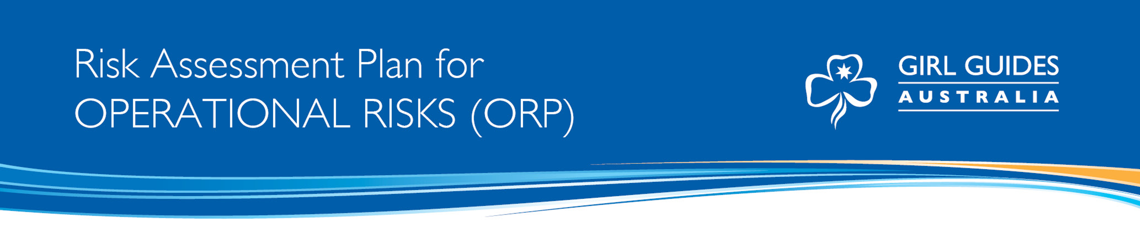

When do I use an ORP?

When you are:

- Undertaking your District, Region or State annual health check
- When big decisions are needed to be made
- When future planning is being done ie
- When deciding on significant financial decisions
- When considering significant building works
- When choosing social media platforms

What do I focus on?

GGA has defined risk areas to assist with identifying operational risks. These are your focus areas when you are considering operational risks in your area ie District, Region, and State. These are listed in table below:

Table 1 GGA RISK AREAS

Key Risk | Explanation
- Governance | Risk to reputation and risk to governing rules (legal liability).
- Guiding (Activities of Guiding) | Risk that activities are not appropriate to the philosophy, principles and method of Girl Guides Australia. Activities are planned that are not suitable and do not meet the developmental needs of the participants.
- People | The physical, emotional, and psychological well-being of all members and participants is paramount.  Includes all members (youth and adult), volunteers, parents, activity providers, general public, business associates and government. This element includes all aspects of risk such as: safety & child protection related to our activities.
- Financial | Financial consequence linked to cost of loss associated with risk, and financial viability of all entities within Girl Guides in Australia.
- Guiding Operations (Business of Guiding) | Day to day running i.e. unit leader-consent forms not completed, activity notification forms not completed.  Includes data integration, marketing, communications, compliance with business legislation, capacity and capability of units/districts/State offices to manage the business side of Guiding.

Instructions for using your ORP

When completing the Risk Assessment Plan for Operational Risks (ORP) follow the steps below:

Step 1
Identify the hazards associated with the key risk areas and then identify the risks associated with the hazards. List them in the columns under step 1.

Step 2
Read tables 1,2,3 below to assess the current level of risk of the hazard. Remember that we already have control measures in place through our policy, procedures, ratios etc so take these into consideration at this stage as we are not starting from a place of no controls.

Firstly, identify the consequences that potentially cause harm using the consequences rating in table 1.

Secondly, identify the likelihood of the consequence occurring using table 2 and decide the most appropriate likelihood.

Thirdly, using the risk rating table (table 3) see what risk rating your consequences and likelihood shows. Record the findings under the column headed step 2.

Step 3
Work out what the best control measures are to reduce the risk of your hazard. These will include current and additional controls. The Hierarchy of Control (table 4) may assist you to make your decision. Record the controls in your step 3 column on your template.

Step 4
Repeat Step 2 and see if your risk rating has reduced to a level that we are prepared to accept. Record your rating in column under step 4.If the risk has not reduced to an acceptable level discuss with your manager. See table 5 Risk Priority table for guidance on when to escalate your risk rating concerns.

Step 5 & 6
Once you have worked out the remaining risk, record the operational action to be taken under step 5 and the person responsible/accountable under step 6.

TABLE 1 Consequence Rating Table

CONSEQUENCE | DESCRIPTION
Insignificant | Low level Impact with negligible consequences on the aim or activity objectives that can be controlled by routine management procedures.  - Governance: eg adverse community sentiment/media article or insignificant breach of governing rule with small breach of consequence.  - Guiding (Activities of Guiding): eg program / activity interrupted for 1 week.  - People: eg minor injury requiring first aid only.  - Financial: i.e. no long term impact eg loss with a negative overall financial impact below the “minor” level.  - Guiding Operations (Business of Guiding): eg key staff unavailable to be contacted in a timely manner.
Minor | The consequences would threaten the efficiency or effectiveness of achieving some aspects of GGA’s aim or activity objectives, requiring management effort to minimise impact. These are defined as:  - Governance: eg informal complaint from parent/member which may result in adverse media over several days; minor breach of governing rules with minor breach consequence.  - Guiding (Activities of Guiding): eg program / activity interrupted for 2-4 weeks.  - People: eg fractured bone, sprain etc. requiring medical intervention.  - Financial: i.e. small loss, short term impact eg loss with a negative overall financial impact below the “moderate” level.  - Guiding Operations (Business of Guiding): eg temporary impact or interruption which may cause slight delay.
Moderate | A significant/medium potential of affecting the achievement of GGA’s aim or activity objectives. These are defined as:  - Governance: eg formal complaint (e.g. written) or material breach of legislation leading to more significant undertaking; failure to follow Guide Lines ratios.  - Guiding (Activities of Guiding): eg program / activity involving 2 or more units is actually or potentially interrupted for more than 4 weeks.  - People: eg suspected abuse or notification of abuse of a youth or adult member; disabling injury.  - Financial: eg cancellation of a national event causing a loss with a negative overall financial impact below the “major” level.  - Guiding Operations (Business of Guiding): – eg short term impact to business operations; loss of data or personnel; short term impact.
Major | A very high potential to impair the achievement of GGA’s aim or activity objectives. These are defined as:  - Governance: eg a breach of legislation; failure to follow ASIC rules.  - Guiding (Activities of Guiding): eg program / activity involving 2 or more regions is actually or potentially interrupted for more than 4 weeks  - People: eg undisclosed health issues; serious injury to personnel; failure to follow Child Protection Policy; death of 1-5 participants, substantiated abuse of a youth member.  - Financial: eg significant fraud; loss of on third of GGA’s or SGGO’s membership; loss with a negative overall financial impact below the “Catastrophic” level.  - Guiding Operations (Business of Guiding): eg significant impact to the business operations; loss of capacity and capability over medium timeline.
Catastrophic | An extreme potential to threaten the sustainability of GGA or its aims and activities. These are defined as:  - Governance: eg. a sustained reputational or legal damage with potential to lead to the collapse/closure of Girl Guides (at a national level or state level); inability of Girl Guides capacity to operate and WAGGGS cancellation of membership of WAGGGS; very serious damage to the reputation.  - Guiding (Activity of Guiding): eg program / activity that if interrupted has the potential to threaten GGA viability.  - People: eg no members; death of more than 5 participants in single but similar activities such as all are abseiling incidents.  - Financial: eg land and assets; insolvency and bankruptcy.  - Guiding Operations (Business of Guiding): eg. Non-compliance of Corporations Act resulting in delisting as a recognised entity.

TABLE 2 Likelihood Rating Table

LIKELIHOOD | DESCRIPTION
Almost Certain | The event is expected to occur in most circumstances. (At least 5 times a year)
Likely | The event will probably occur in most circumstances. (At least twice a year)
Possible | The event might (or could) occur at some time. (At least once a year)
Unlikely | The event will probably not occur. (At least once in five years)
Rare | The event may only occur in exceptional circumstances

TABLE 3 Risk Analysis Matrix

LIKELIHOOD RATING | CONSEQUENCES – what is the maximum reasonable consequence?
 | Insignificant | Minor | Moderate | Major | Catastrophic
Almost Certain | Medium | Medium | High | Extreme | Extreme
Likely | Low | Medium | Medium | High | Extreme
Possible | Low | Low | Medium | High | High
Unlikely | Low | Low | Low | Medium | High
Rare | Low | Low | Low | Low | Medium

TABLE 4 Hierarchy of Control

You may like to use the Hierarchy of Control and its levels to help you work out the best control for your risks. Start at the top (Level 1) for the most effective way of reducing your hazard and work your way down until you are happy that you have controlled your risk.

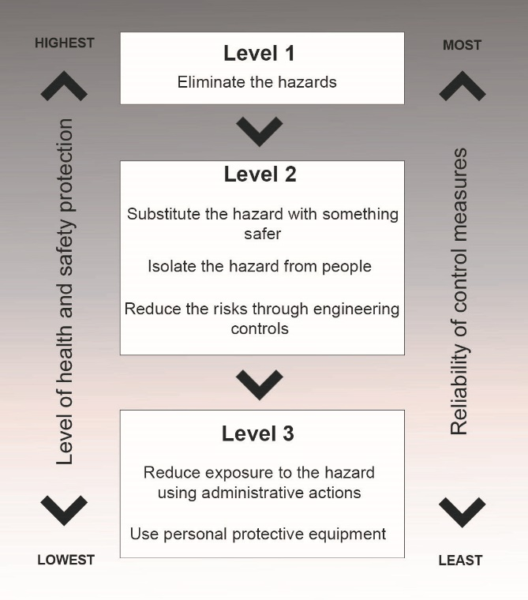

TABLE 5 Risk Priority Table

RISK PRIORITY | ACTION
Extreme | An Extreme Risk is one that must be dealt with immediately. State Girl Guide Organisations and Girl Guides Australia Boards normally monitor Extreme Risks.
High | A High Risk is one that should be dealt with after attending to Extreme Risks. High level risks may be managed at State Commissioner or Executive Officer level or at the level of the Risk Management Representatives at SGGO level.
Medium | A Medium Risk is one that can be dealt with by applying routine procedures and is normally dealt with by Region and/or District Managers. Where appropriate, medium level risks may be escalated to the Executive Officer or State Commissioner level.
Low | A Low Risk is accepted and controlled by the leader but should be monitored periodically by Region and/or District Managers to ensure the rating does not change.

Elimination

Risk Assessment Plan for Operational Risks (ORP)

Name of activity (policy, procedure, process):

Date completed: |  | Prepared by:
Date reviewed: |  | Reviewed by:
.

Step 1  Identify the hazards |  | Step 2  Assess the current risk,  use tables 1,2,3 | Step 3  Control the risk | Step 4  Assess the remaining  Risk, use tables 1,2,3 again. | Step 5  Action to be taken | Step 6  Accountable person to implement action  & date by
Identify the hazards | What is the harm associated with the hazard? | Is the risk low, medium, high or extreme? | What controls are already in place and what else needs to be done to reduce or remove the risk? | Now that controls have been put in place reassess the risk. | List the actions to be taken | List the person who will implement the action
Governance
Guiding (Activities of Guiding)
People
Financial
Guiding Operations (Business of Guiding)

